Types of winds:

Primary wind or planetary wind

Primary winds constantly blow throughout the year in a particular direction. Primary winds are also known as prevailing winds or planetary winds.

Different types of primary wind:

Trade wind, the westerlies, and easterlies.

Trade Wind:

Trade winds blow from the right in the Northern hemisphere and left in the Southern hemisphere due to the Coriolis effect and Ferrel’s law.(Spinning of the earth about its axis produces a coriolis force.)

The Coriolis force is perpendicular to the object's axis. The Earth spins on its axis from west to east. The Coriolis force, therefore, acts in a north-south direction. The Coriolis force is zero at the Equator.

Secondary wind or periodic wind

Secondary winds are winds that change their direction in different seasons. Secondary winds are also known as seasonal winds and periodic winds. Secondary winds occur in many locations throughout the world. A particular secondary wind and the underlying physical forces that drive the wind depend upon the unique geographic location. One of the most commonly recognized secondary winds is the monsoon wind.

Tertiary wind or Local wind

Tertiary winds blow only during a particular period of the day or year in a small area. These winds blow due to the difference in temperature and air pressure of a specific location. These winds can be of different types, like hot, cold, ice-filled, dust– rich, in accordance with local characteristics. Loo is a hot and dry local wind of the northern plains of India. Other main local winds include Mistral, Foehn, Bora, etc.

The equatorial and tropical regions (close to the equator) get the maximum heat from the sun; hence they get hotter than the polar regions. The air surrounding this region gets heated up and rises to create a vacuum. Cooler air from the poles rushes to fill the vacuum

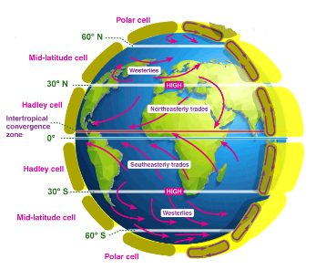

The main cause of generation of wind is the uneven heating of two regions.

Seawater gets heated more slowly as compared to land. As the temperature of the land rises, the air above it gets heated by conduction. The density of warm air is less than the surrounding environment, because of which it rises, creating a vacuum in its place. The cooler air from the sea rushes to fill the vacuum which creates a cool coastal breeze. At night, the land cools off more quickly, which creates a temperature difference between the temperature onshore and that offshore. Because of this temperature difference, again, a pressure drop is created, establishing a land breeze.

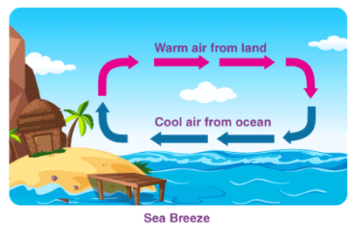

Wind Data:

Anemometers work on one of the following principles:

1.The oldest and simplest anemometer is a swinging plate hung vertically and hinged along its top edge.Wind speed is indicated by the angle of deflection of the plate with respect to the vertical.

2.A cup anemometer consists of three or four cups mounted symmetrically about a vertical axis.The speed of rotation indicates wind speed.

3.Wind speed can also be recorded by measuring the wind pressure on a flat plate.

4.A hot wire anemometer measures the wind speed by recording cooling effects of the wind on a hot wire.The heat is produced by passing an electric current through the wire.

5.An anemometer can also be based on sonic effect .

Advantage and Disadvantages of wind:

Adv:

1.It is renewable Energy

2.Non polluting

3.Fuel transport are not required and resource is available in adundance.

4. Economically competitive.

5.Ideal choice for rural and remote areas and area which lack other energy sources.

Dis Adv:

1. Need battery storage.

2. Energy fluctuates.

3. Overall weight is high.

4. Noisy

5. Large area required for installation/ operation of wind energy.

6. Favourable winds are available only in a few geographical locations.

7.Wind turbine design is complex one.

8.Wind forms requires flat , vacant land .

Environmental impacts:

1.Creates noise pollution.

2.Unsafe for wild animals and birds.

3.safty consideration of life because of accidental braking of blades.